Fyvie School Newsletter

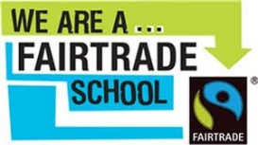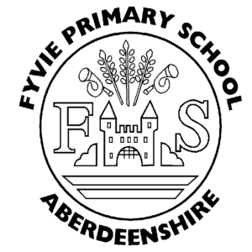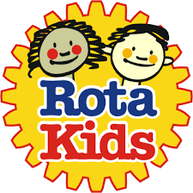

November 2023

HALLOWEEN DISCO
A huge thank you to the Parent Council for running a very popular and enjoyable disco for the children within the school. Many fantastic costumes were worn and the children who attended had a great time.

CHILDREN IN NEED
The Rota Kids group are selling merchandise this week to fundraise for Children in Need. If your child wishes to purchase an item please note that these are all priced at £1 and limited to one item per child. They will be avaiable in the morning before bell in the foyer at the bottom of the stairs.

PARENTS EVENING
Wednesday 15th November.
Please don’t forget to sign up, if you haven’t already. Any problems signing up, please don’t hesitate to contact the office.

WINTER WEATHER
It is very important that your child comes to school dressed appropriately for the colder and wetter weather that is now upon us. As a minimum ALL pupils should come to school every day with a jacket so they are happy, warm and dry at break and lunch. In addition, every class goes outdoor learning for a block of time once a week. The class go out in all weather conditions, so the children really do need to have the following to wear - wellie boots, waterproof jacket (with a hood) and trousers, hat and gloves on these days.

OUTDOOR LEARNING DAYS IN TERM TWO
P1/2 - Tuesday
P2/3/4 - Friday
P4/5 - Thursday
P5/6 - Thursday
P6/7 - Monday

CHRSITMAS LIGHTS SWITCH ON
Fyvie & District Amenities Committee Christmas lights switch on is on Friday 24th November at 6.30pm at Forbes-Leith Park. You are then invited to the Royal British Legion for mince pies and mulled wine or hot chocolate afterwards.

ST ANDREWS DAY
Please feel free to wear something tartan to school on Wednesday 30th November to celebrate St Andrew’s day.

SNOW!
After the unprecedented levels of snow (and rain!) in years gone by, we are again getting prepared for the worst. The closing of the school is a very difficult decision and is never one that I take lightly. Overall, the safety of the pupils and my staff comes first. Guidance for parents on snow and schools can be found on the council website.

In the first instance of bad weather please phone the Aberdeenshire Council phone line for severe weather tel 0870 054 4999 Fyvie’s pin number is 021790. Alternatively log on to the school closures website.
http://www.aberdeenshire.gov.uk/closures

CHRISTMAS FAIR
The Fyvie School Parent Council Christmas Fair will take place on Saturday 25th November from 10am –
1pm. With lots of fantastic stalls ranging from class enterprises to small businesses, teas and coffees, a raffle and a special guest to meet the children there is something for everyone! We are going to have Santa's grotto booking form emailed out via the school. We are looking for helpers to help set up on Friday 2pm and to help on Saturday time slots 9-11.30 or 11.30-1.30pm. Please get in touch if you can help out.

CHRISTMAS CAFE
The whole school will present a medley of Christmas songs to entertain parents and friends of Fyvie on Friday 15th December, this will follow the same format as for the MacMillan Café, each classes time to be confirmed shortly.

CHRISTMAS POST BOX
The Fyvie School “posties” from P7 will set to work delivering Christmas cards from Monday 4th December and every day after. If your child would like to write and send cards to their friends in the school they can post them in our special Christmas post box that is in the school corridor. Please note that sweets and chocolates should not be put in the cards.

SAVE THE CHILDREN CHRISTMAS JUMPER DAY
Thursday 7th December
After its success last year, staff and pupils are again invited to wear a festive jumper to school to raise money for Save the Children, more details to follow from the Rights Respecting group.

This is also the day that we will have our Chrsitmas lunch prepared by the dinner ladies. See previous communication for more information on this.

PARENT COUNCIL
The next meeting will take place on Monday 11th December at 6.30pm in the staff room. Do come along and get involved! All parents are welcome to attend. The Parent Council have a Facebook page which you can ‘like’ to keep up to date with Parent Council information – click this link or search Fyvie School Parent Council using the Facebook search bar. https://www.facebook.com/Fyvie-School-Parent-Council/#!/pages/Fyvie-School-Parent-Council/256450104388427?fref=ts

CHRISTMAS PARTIES
Tuesday 19th December P1/2 and P2/3/4
Wednesday 20th December P4/5 class and P5’s from the P5/6 class
Thursday 21st December P6’s from the P5/6 class and P6/7

On your child’s party day, with the exception of our Nursery children, they should wear their normal school clothes and take their party clothes with them in a bag. Children will then be invited to change into their party clothes at the beginning of the afternoon session.

Parent Council are kindly donating snacks.

PANTO VISIT
We are really looking forward to having the visiting panto on the last day of term.

It is super to be back and working with Mrs Hendry. Lovely to see all the staff and children again too. As you may be aware we are working together with the whole school to improve behaviour and safety around the school. We have shared the School Positive Behaviour policy with the Parent Council for feedback and continue to work with individual pupils whose behaviour requires individualised interventions.

Mrs A Craig
Head Teacher

We are always interested to hear your views. Please feel free to write/email us/phone us with your comments.
fyvie.sch@aberdeenshire.gov.uk
01651 267400

